***Team International AQA Bootcamp Task 1: Git***

**Student:***Nahuel Rodríguez Maury*

**Part 1:** Repository initialization and first commit

1. Open Git Bash from Start:

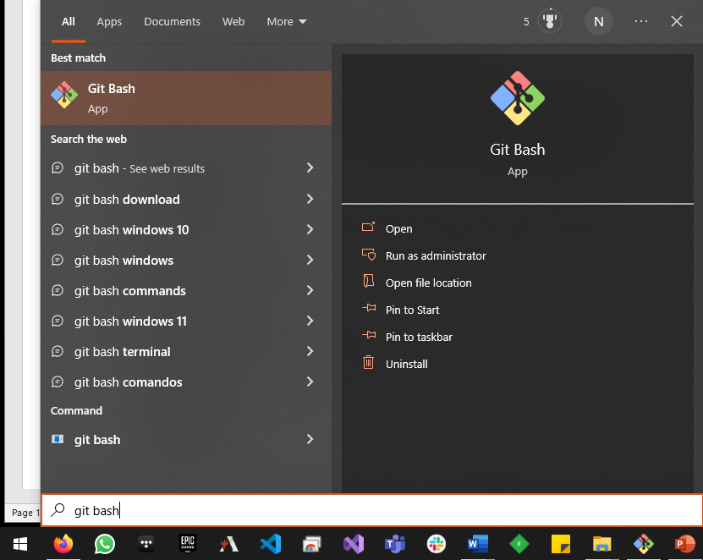  
  
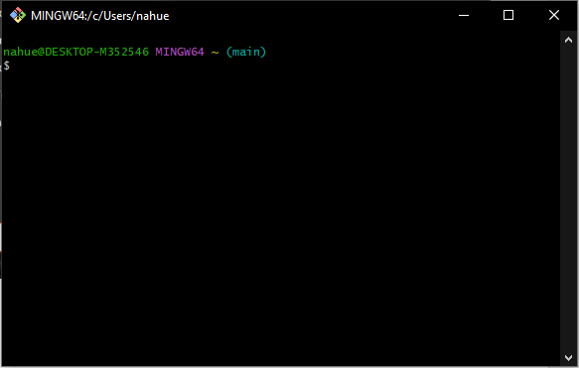

1. Move to desktop:

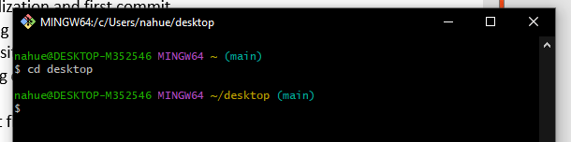

1. Create a working directory:

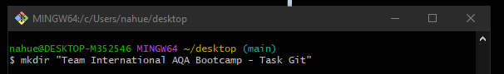



1. Enter into the folder:

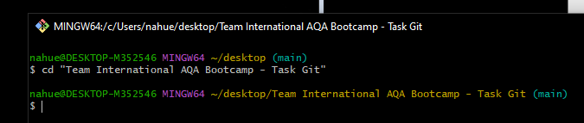

1. Initialize the repository:

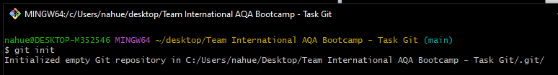

1. Customize the config file:

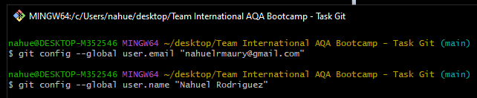

1. Create a working directory in it:

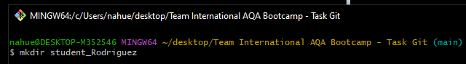

1. Enter into the new folder and create 3 project files:

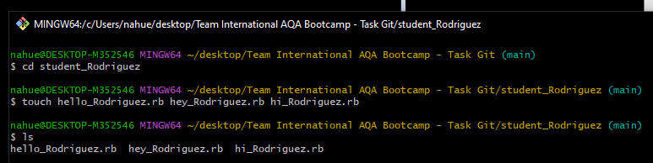

1. Move back and check repository status:

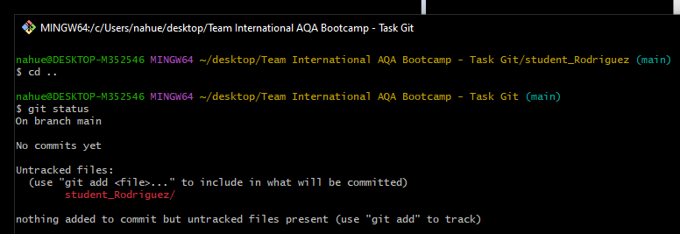

1. Index the files and make the first commit:

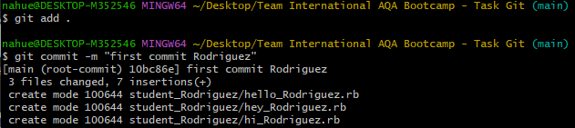

1. Make changes to files:

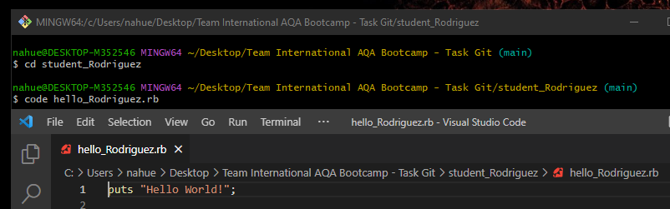

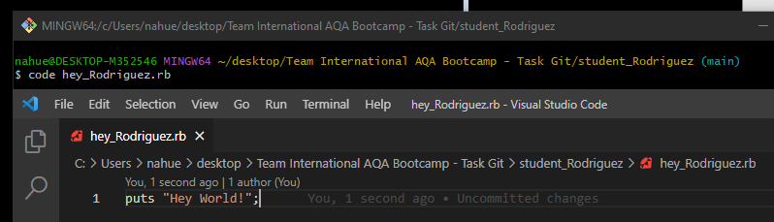

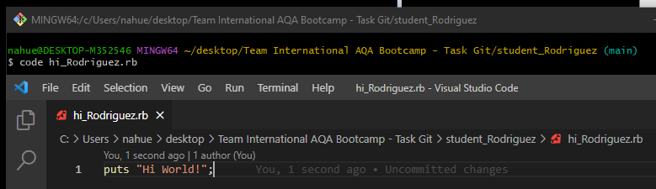

1. Index the files and make a commit of the changes:

(I did not was sure about this step, because the task just says to make a commit, but I index the files before that so It can commit it correctly)

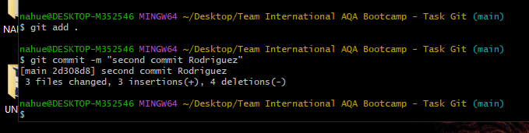

**Part 2:** Working with changes

1. Make changes to the first file:

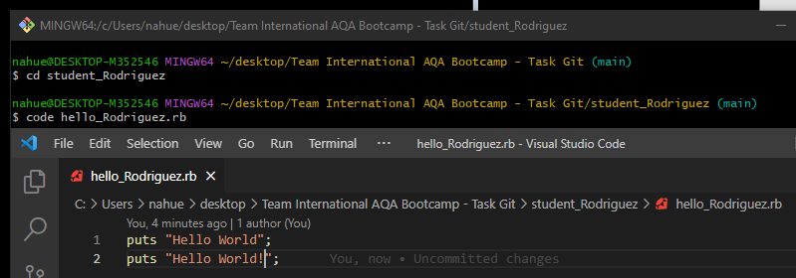

1. Index the file:

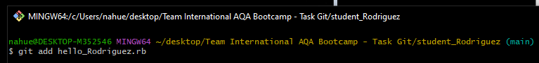

1. Make new changes to the first file:

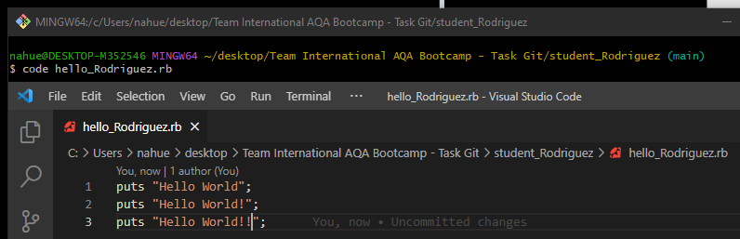

1. Check status:

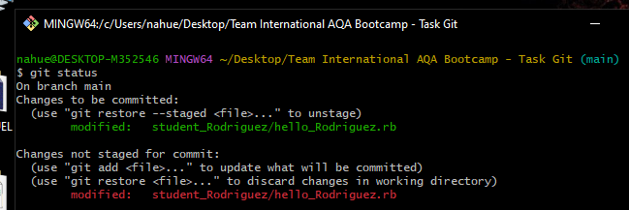

1. Make commit and check status:

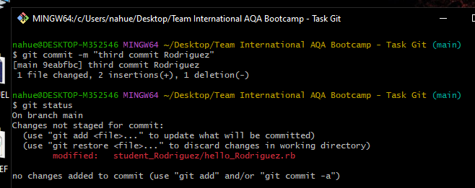

1. Explain the result:

I first made changes to the first file and then tracked it with “git add hello_Rodriguez.rb”, this way I move it to staging area. After, I made more changes to the first file. Then, I committed, and the result was that the first changes were committed and passed to the local repository and the second changes stayed in the working directory.

1. Display the history of the project:

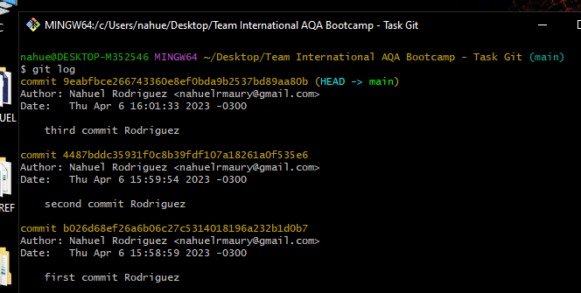

1. Use the command git log –pretty=oneline, adjusting relevant options to display the latest commits for 5 minutes:

If I had used –pretty=oneline, it would not show relevant options. So, I had to give it some format.

Command used: git log --pretty="%C(Yellow)%h %C(reset)%ad (%C(Green)%cr%C(reset))%x09 %C(Cyan)%an: %C(reset)%s" --date=short -7 --since="5 minutes ago"

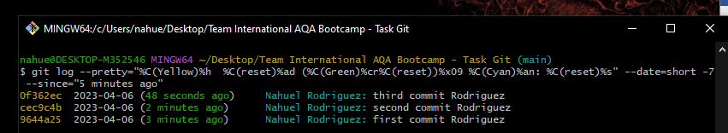

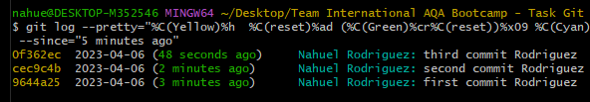

**Part 3:** Working with the previous states of the repository

1. Revert the state of the files:

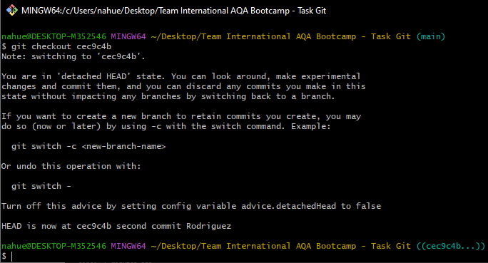

1. Revert the state of the files to the latest commit:

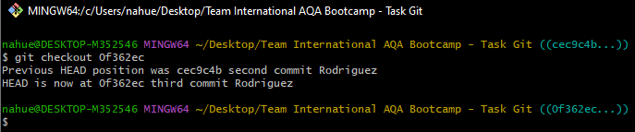

**Part 4:** Working with tags

1. Create a tag in the current repository snapshot:

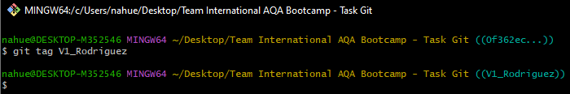

1. Make changes and at least two commits in the current directory:

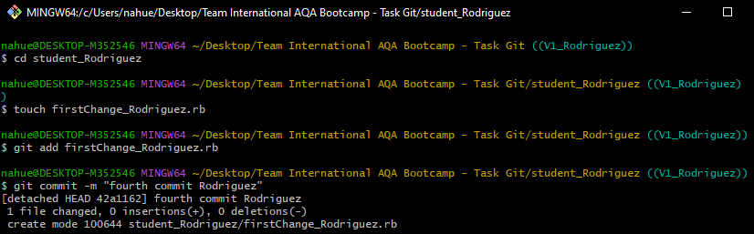

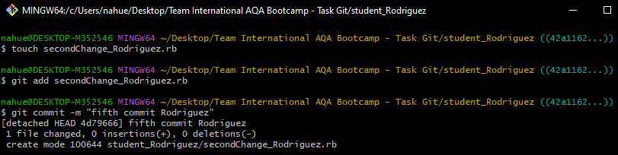

1. Demonstrate reverting to a tagged repository state:

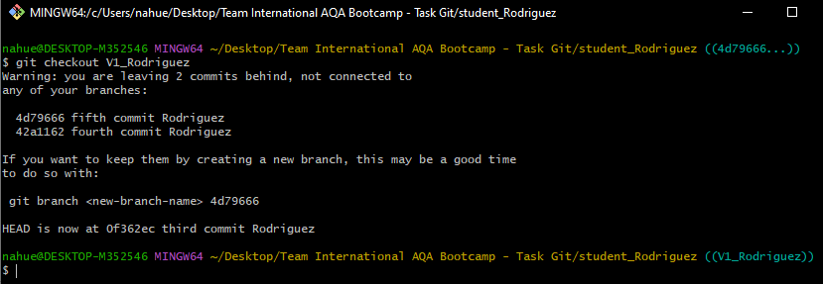

1. Revert to the last master state:

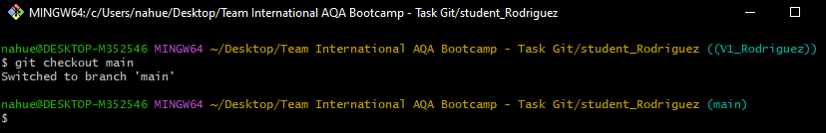

**Part 5:** Working with the revert function

1. Make changes to the current state of the working directory:

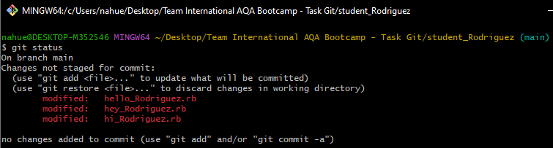

1. Index the changes:

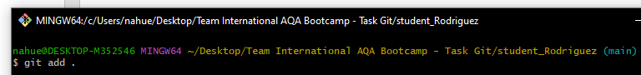

1. Use the restore command to restore the original state of the files:

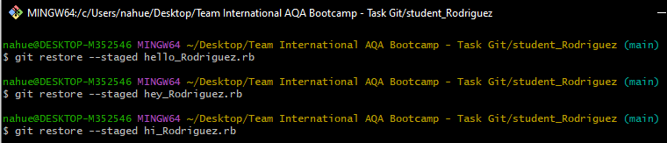

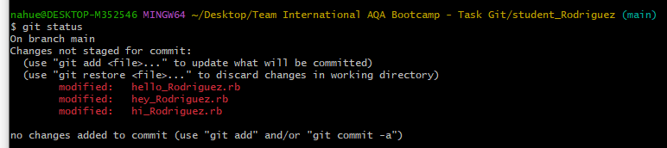

1. Make directory state changes:

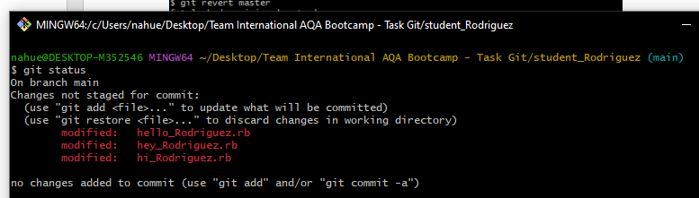

1. Index and commit:

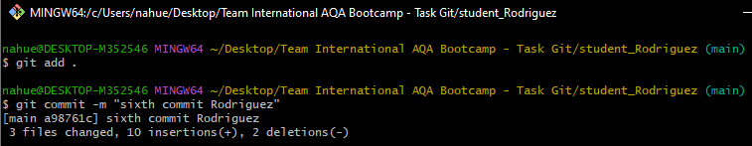

1. Revert the last commit:



1. Show log:

